
Expo Booth
I would like to book a Table Booth during for the Global WaterTech Summit & Expo 2026 on 21st August 2026.
Organization Name:

Address:
Contact Person Name:
Contact Person Designation:
Mobile No.:
Email:
Website:
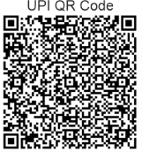
Booth Space
INR 40,000
Plus 18% GST

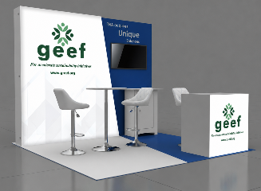
Please complete the form at Global Energy & Environment Foundation
Email: geef.foundation@gmail.com | 011-45536559 A/c No.: 922020067406587
www.g-eef.org Bank Name: Axis Bank Ltd.
RTGS / NEFT / IFSC: UTIB0003047
Table Booth Facilities are;
• One Table & Chairs
• Fascia / Name display of the organization
• Display opportunity for standee
• Two (2) complimentary delegate registrations
______________________________________________________________________________________________________
For Speakership | Sponsorship For Registration | Booth Space
Punit Singh Nagi Uttam Sharma
Project Director Deputy Manager
Email: punit.nagi@g-eef.org Email: uttam.sharma@g-eef.org
Cell: 91 9213901510 Cell: 91 9968103707

